Ireland Crime Statistics
Using Tableau and Weka

Choosing the Dataset
The dataset I chose is concerned with real world problem that lends itself to easy understanding of everyone. It is called Garda Stations on which I’m doing the analysis on Irish crime statistics. After preprocessing the dataset contained 18 attributes and 7319 instances.

Title:

Ireland Crime Statistics
The objective to select that dataset is to see the relationship between the variables and attributes and the occurrence of crimes in different cities in the years between 2004 and 2016.
Problem domain:
Where are the most crimes happening and what are the years of these crimes happening commonly and vastly.
Data description:
Country: Ireland

Format
Files called garda_stations.csv
A data frame containing:
- id: Identifier
- x: geographical identifier
- y: geographical identifier
- Station: Garda stations of Ireland
- Divisions: Garda station divisions of Ireland
- City: Cities where the crimes have reported
- Year of Crime: year of crimes happened from 2004 to 2016
- Attempts or threats to murder, assaults, harassments and related offences
- Dangerous or negligent acts
- Kidnapping and related offences
- Robbery, extortion and hijacking offences
- Burglary and related offences
- Theft and related offences
- Fraud, deception and related offences
- Controlled drug offences
- Weapons and Explosives offences
- Damage to property and to the environment
- Public order and other social code offences

Source of the data

Crimes at Garda Stations Level 2010-2016

https://data.gov.ie/dataset/crimes-at-garda-stations-level-2010-2016/resource/61483d87-1555-4887-a929-82255f7187cf?inner_span=True

The data set is called Crimes at Garda Stations Level 2010-2016. It is Published by: All-Island Research Observatory and Licensed under: Creative Commons Attribution 4.0
The Theme of this dataset is Society. This dataset contains original variables from the CSO regarding criminal offences recorded in the 563 Garda Stations in the Republic of Ireland is available on an annual basis from 2004 to 2016*.

Objective:
The current dataset contains over 2004 to 2016 of crimes reported in different cities and garda stations. The objective to analyse this data is to see the patterns and behaviour of the crimes over the time in big cities, also to see which crimes have happened in large amount in these years and where these crimes have been happening.

Preprocessing

For preprocessing of this dataset, I merged all years of crimes in to one column and made another column called years of crime. I added the city column and add in the cities names according to the stations and divisions of Ireland given in the dataset.

Original Data in CSV file:

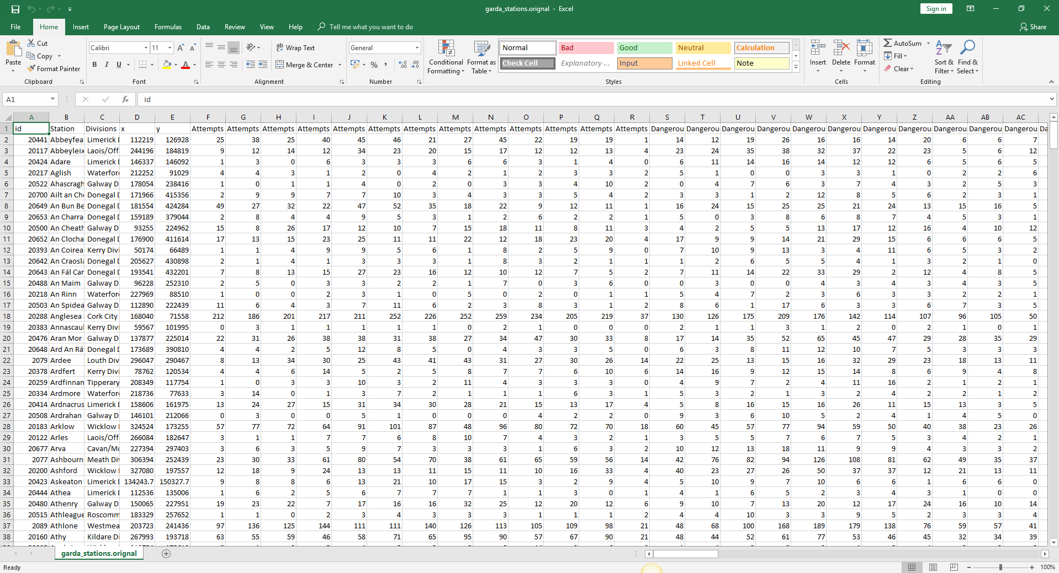

Preprocessed Data in excel file:

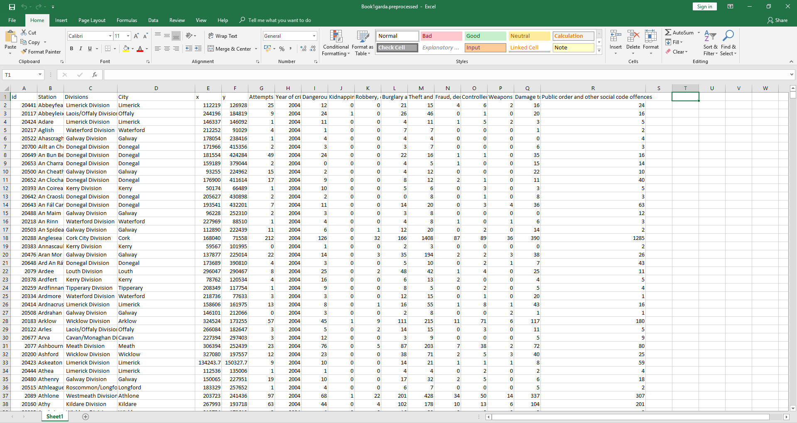

Pre-processed data in Tableau:

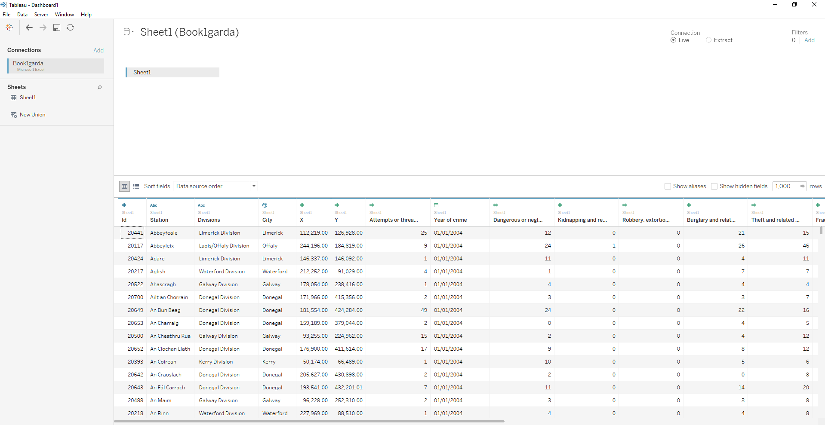

Dashboard 1:
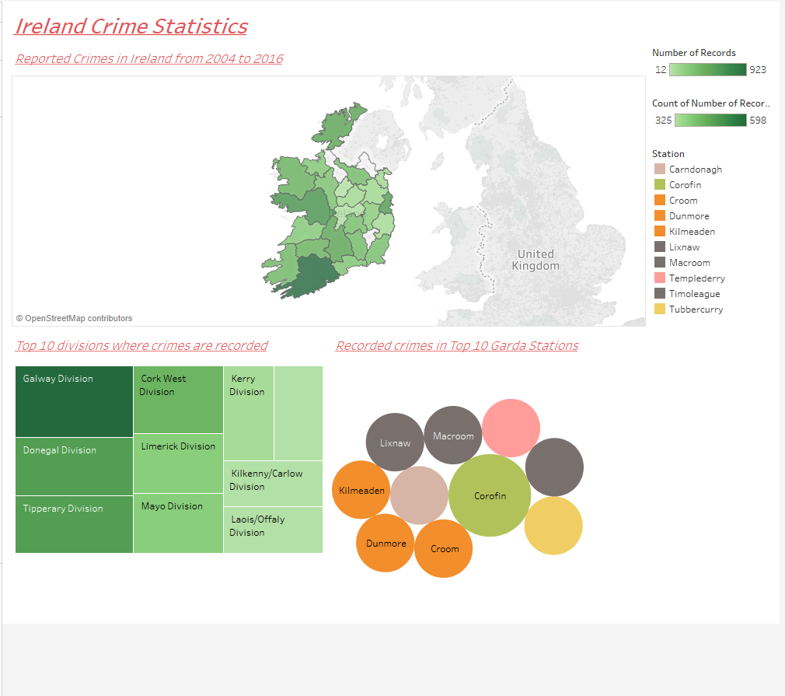

Ireland crime statistics: Dashboard 1
In dashboard 1 I took the most recorded and reported crimes in cities of Ireland from 2004 to 2016. There is the map that is explaining the dark colours which is Galway, has the most crimes reported and light colour has the least amount of reported records. In the next sheet I took top 10 divisions of Ireland where the most crimes recorded, you can see that Galway division has the most numbers of crimes reported. In third sheet of the dashboard I took recorded crimes in top ten garda stations and Corofin has the most crimes reported.

Dashboard 2:
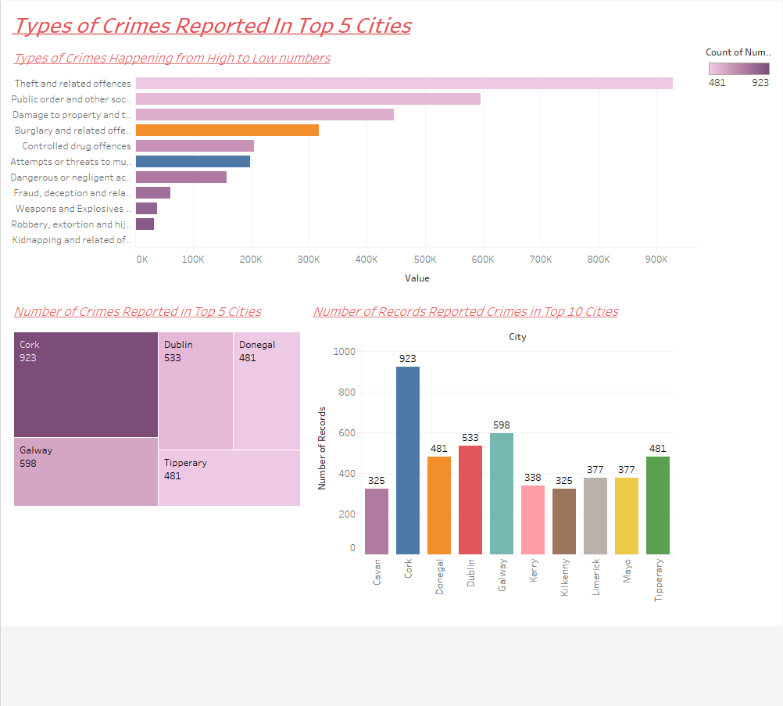

Types of Crimes reported in top 5 cities: Dashboard 2
In dashboard 2 I took all the types of crimes reported in cities of Ireland from 2004 to 2016 happening from high to low numbers. Theft and related offences has the top position in the crimes. In the next sheet I took top 5 cities of Ireland where the most crimes recorded, you can see that Cork has the most numbers of crimes reported. In third sheet of the dashboard I took recorded crimes in top ten cities and Cork has the most crimes reported.

Dashboard 3:
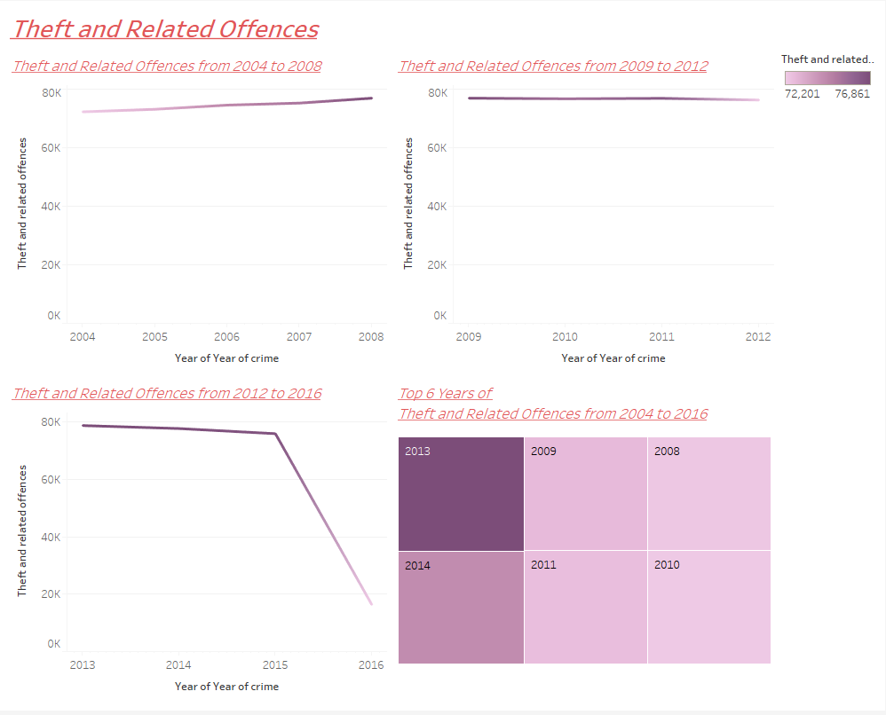

Theft and related offences: Dashboard 3
In dashboard 3 I took the top-level offence theft and related offences from 2004 to 2016 and analysed the activity of this offence in three chunks e.g.2004 to 2008, 2009 to 2012, and 2013 to 2016. The line graph is getting high at 2013, 2014, 2009, 2011, 2008 and 2010 but it is getting low and down at 2016; that means that the theft and related offences are going low in 2016. In the fourth sheet I took top 6 years of theft and related offences from 2004 to 2016. 2013 is the year of most theft and related offences.

Dashboard 4:
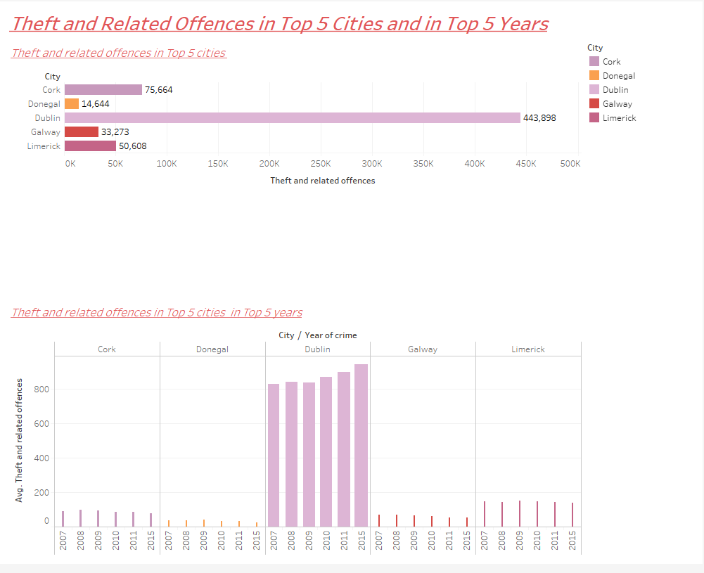

Theft and related offences in top 5 cities in top 5 years: Dashboard 4
In dashboard 3 I took theft and related offences from 2004 to 2016 and analysed the activity of this offence in top 5 cities. Dublin, Cork, Limerick, Galway and Donegal was in top 5 cities in relation to the theft related offences, Dublin was on top with 443,898 cases of this offence. The years when most of these offences happened in Dublin are 2007, 2008, 2009, 2010, 2011 and 2015, Where 2015 has the top position.

Dashboard 5:
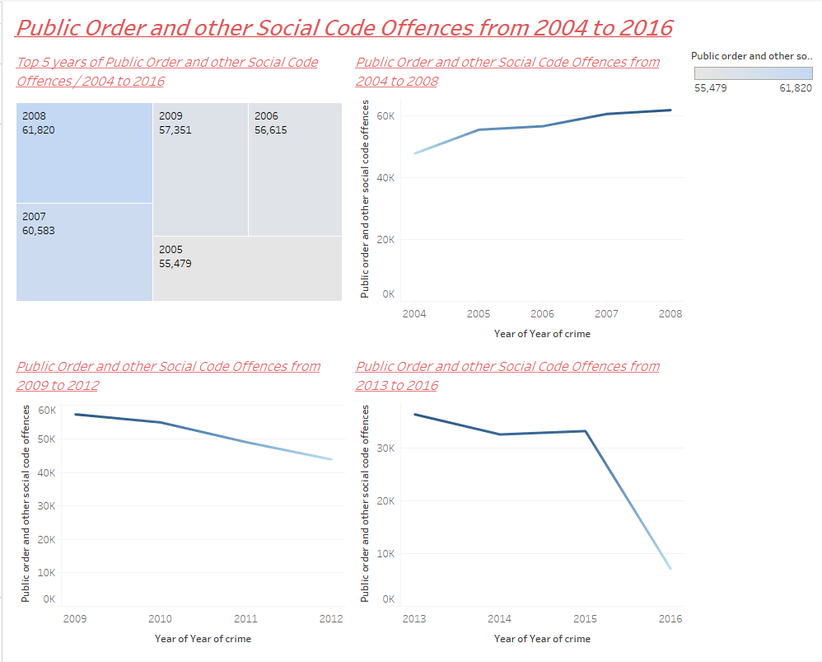
Public order and other social code offences from 2004 to 2016: Dashboard 5
In dashboard 5 I took the second-level most happened offence Public order and other social code offences from 2004 to 2016 and analysed the activity of this offence in three chunks e.g.2004 to 2008, 2009 to 2012, and 2013 to 2016. The line graph is getting high at 2008, 2007, 2009, 2005 and 2006 but it is getting low and down at 2016; that means that the Public order and other social code offences from 2004 to 2016 are going low in 2016. In the first sheet I took top 5 years of Public order and other social code offences from 2004 to 2016. 2008 is the year of most Public order and other social code offences.

Dashboard 6:
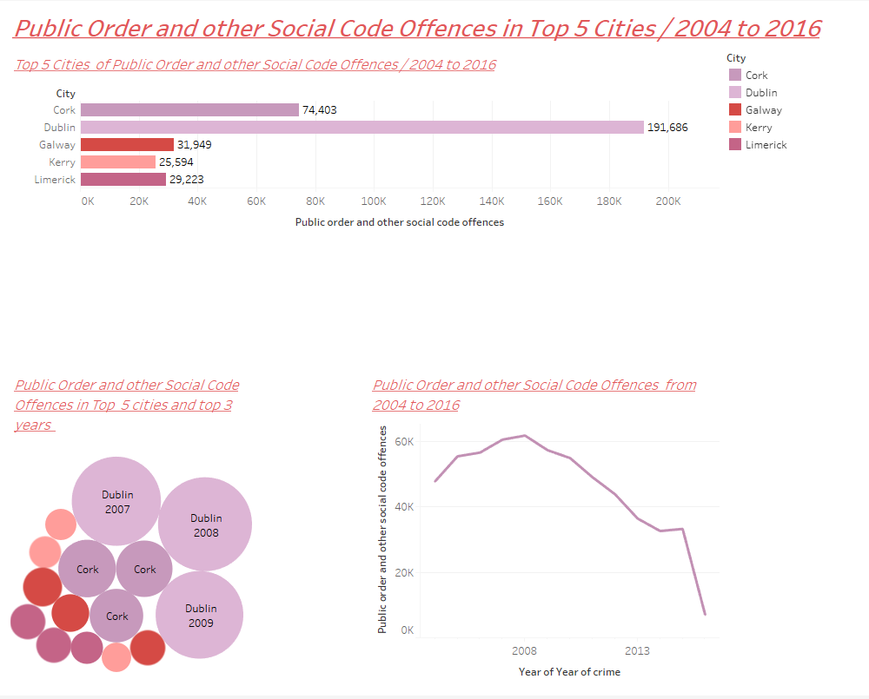

Public order and other social code offences from 2004 to 2016: Dashboard 6
In dashboard 6 I took Public order and other social code offences from 2004 to 2016 and analysed the activity of this offence in top 5 cities. Dublin, Cork, Galway, Limerick and Kerry were in top 5 cities in relation to the Public order and other social code offences from 2004 to 2016, Dublin was on top with 191,686 cases of this offence. The years when most of these offences happened in Dublin are 2007, 2008 and 2009, Where 2008 has the top position.

Dashboard 7:
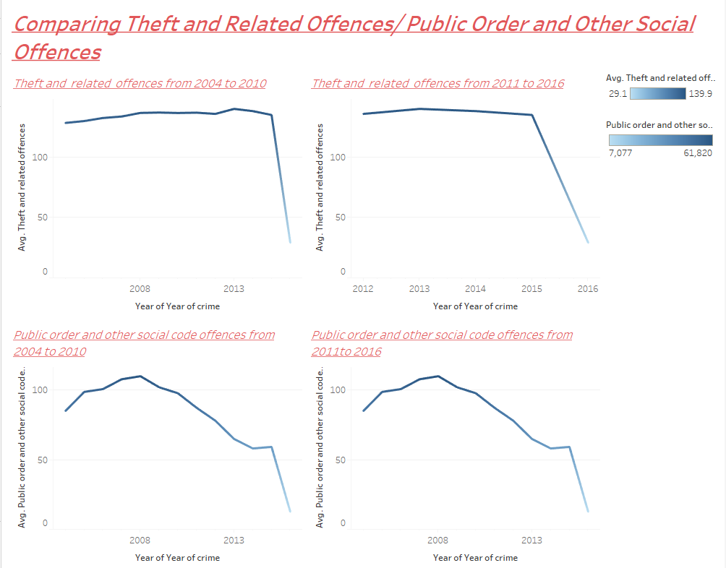
Comparing Theft and related offences / Public order and other social code offences from 2004 to 2016: Dashboard 7
In dashboard 7 I took the first and second-level most happened offences Theft and related offences vs Public order and other social code offences from 2004 to 2016 and analysed the activity of these offences in two chunks e.g. 2004 to 2010 and 2011 to 2016. The line graph of Theft and related offences is getting high at 2013, 2014, 2009, 2011, 2008 and 2010 but it is getting low and down at 2016.The line graph of Public order and other social code offences is getting high at 2008, 2007, 2009, 2005 and 2006 but it is getting low and down at 2016. That means that the both offences are going low in 2016. 2013 is the year of most Theft and related offences while 2008 is the year of most Public order and other social code offences.

Dashboard 8:
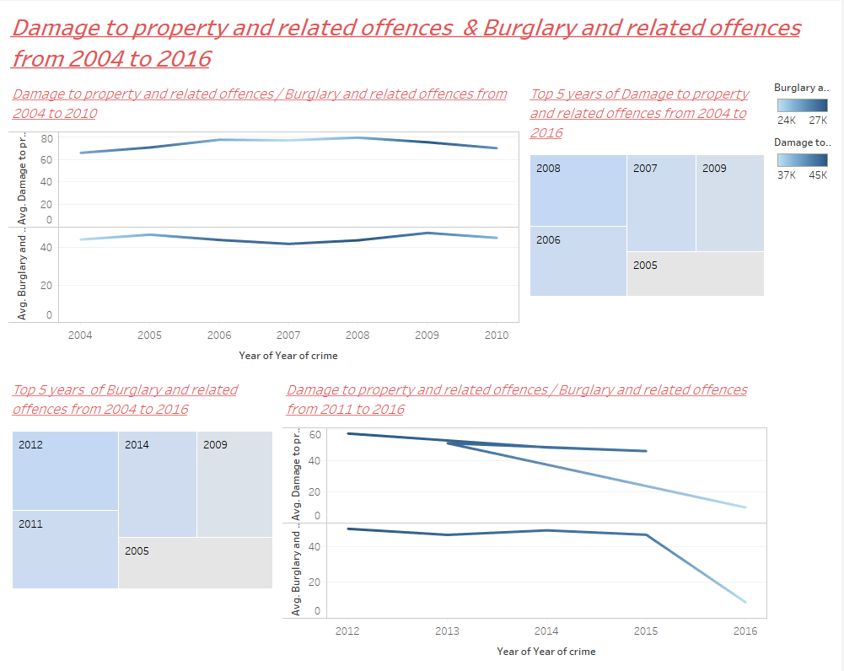
Damage to property and related offences / Burglary and related offences from 2004 to 2016: Dashboard 8
In dashboard 8 I took Damage to property and related offences / Burglary and related offences from 2004 to 2016 and analysed these offences activities in two chunks 2004 to 2010 and 2011 to 2016. Damage to property and related offences were at high level in 2008, 2006, 2007, 2009 and 2006; while Burglary and related offences were high in 2012, 2011, 2014, 2009 and 2005. These both offences are also declining in 2016.

Dashboard 9:
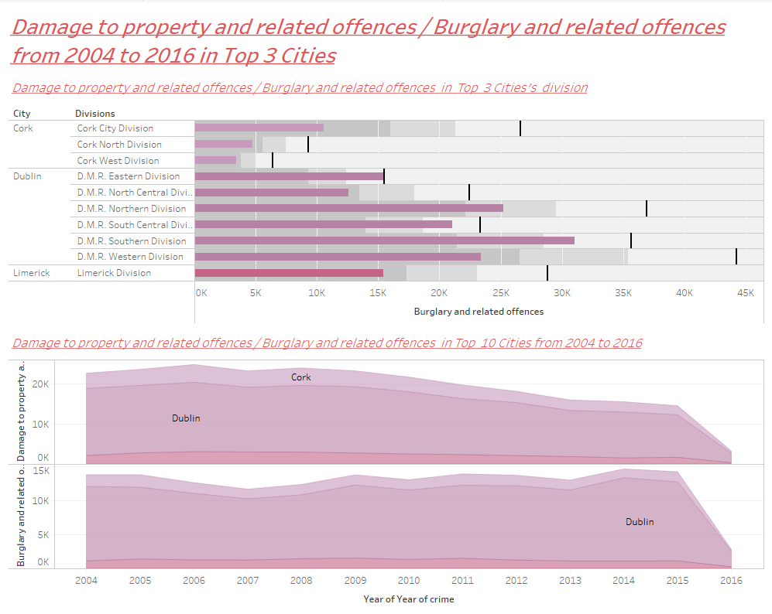

Damage to property and related offences / Burglary and related offences from 2004 to 2016 in top 3 cities: Dashboard 9
In dashboard 9 I took Damage to property and related offences / Burglary and related offences from 2004 to 2016 and analysed the activity of these offences in top 3 cities and divisions. Dublin’s D.M.R southern division, Cork’s city division and Limerick’s limerick division were in top 3 cities and divisions in relation to the Damage to property and related offences / Burglary and related offences from 2004 to 2016. Dublin was on top of these offences. The years when most of Damage to property and related offences / Burglary and related offences happened in Dublin are 2006 and 2015 respectively.

Dashboard 10:
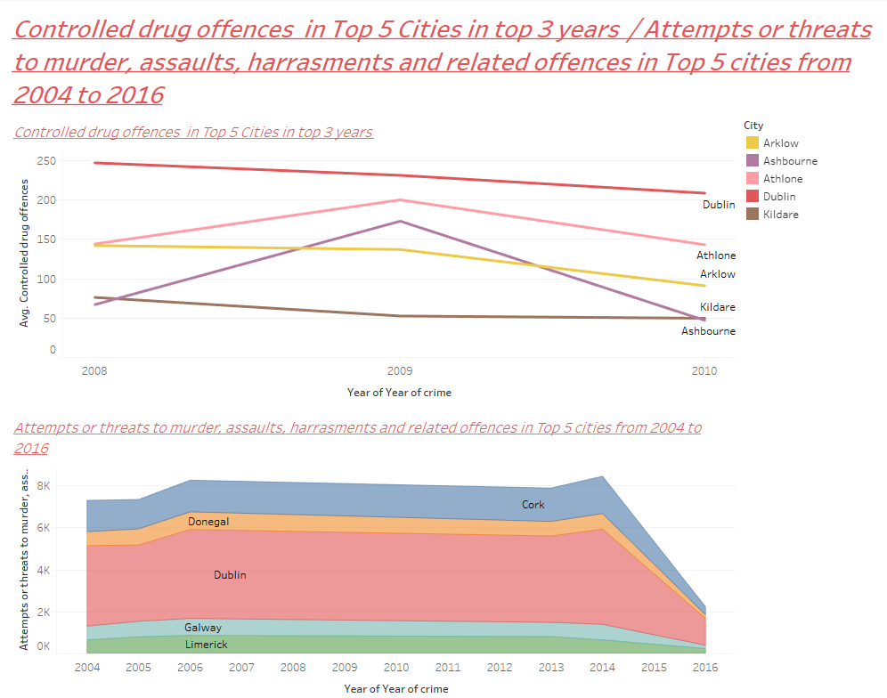

Dashboard 11:

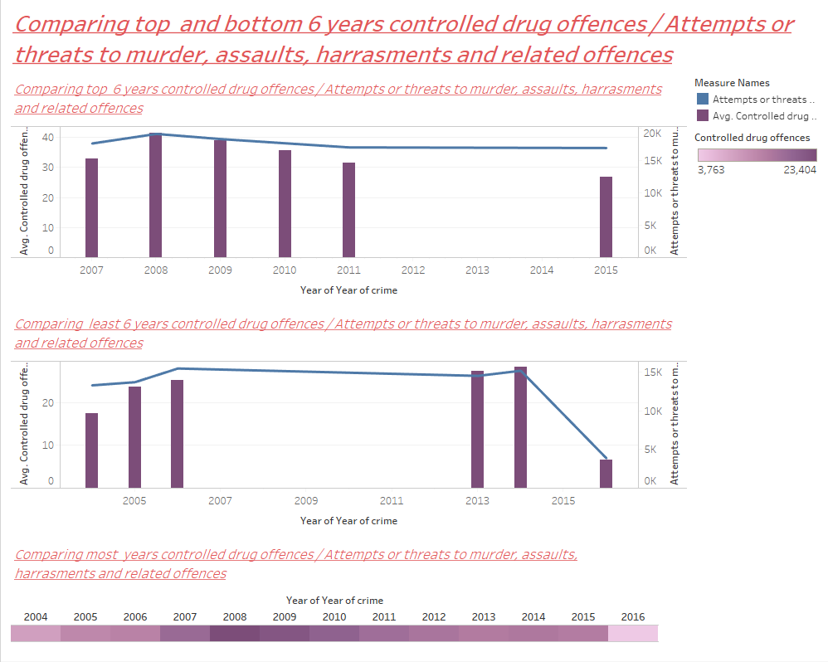

Controlled drug offences / Attempts or threats to murder, assaults, harassments and related offences from 2004 to 2016 in top 5 cities: Dashboard 10 and 11
In dashboard 10 and 11 I took Controlled drug offences / Attempts or threats to murder, assaults, harassments and related offences from 2004 to 2016 and analysed the activity of these offences in top 5 cities. Dublin, Athlone, Arklow, Kildare and Ashbourne in relation to the Controlled drug offences were in top 5 cities respectively; These offences were high in 2008, 2009 and 2010. Attempts or threats to murder, assaults, harassments and related offences from 2004 to 2016 in top 5 cities were Dublin, Cork, Donegal, Galway and limerick respectively. These offences were high in 2008 and 2015.

Dashboard 12:

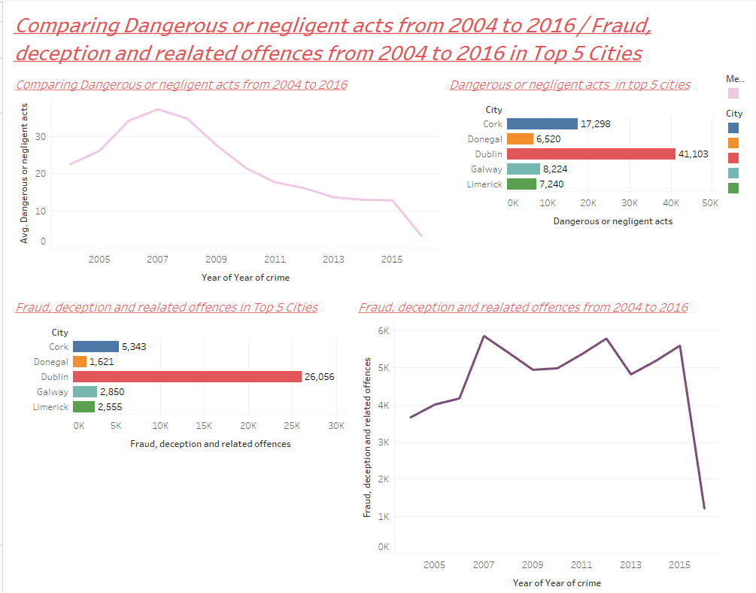

Dashboard 13:

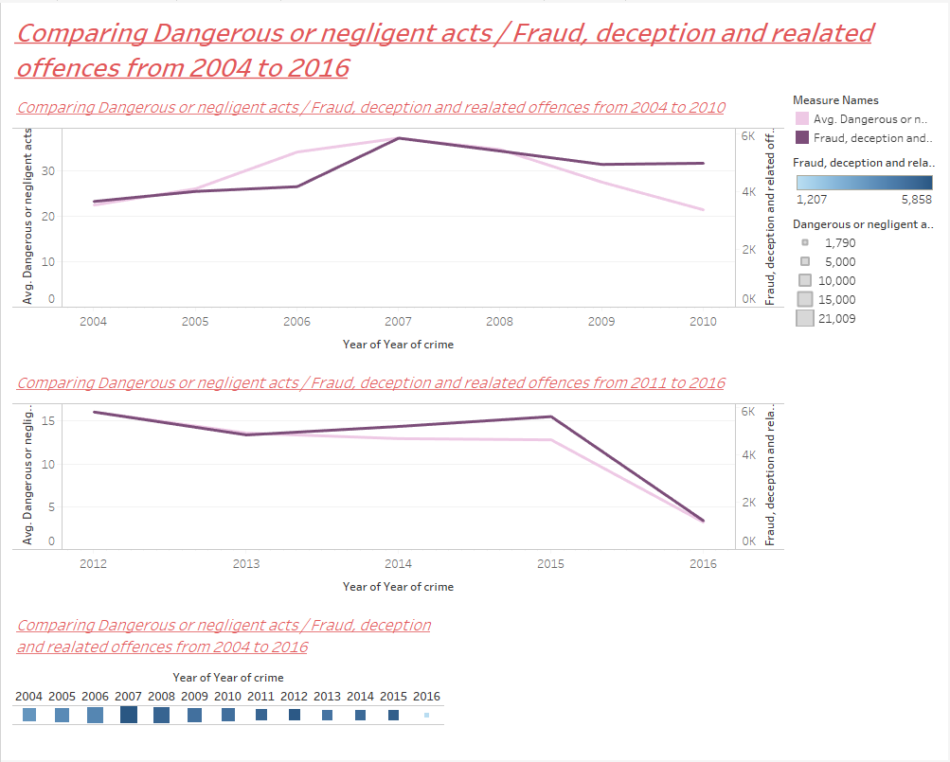
Comparing Dangerous Negligence Acts / Fraud, Deception and related offences from 2004 to 2016 in top 5 cities: Dashboard 12 and 13
In dashboard 12 and 13 I took Dangerous Negligence Acts / Fraud, Deception and related offences from 2004 to 2016 and analysed the activity of these offences in top 5 cities. Dublin, Cork, Galway, Limerick and Donegal in relation to the Dangerous Negligence Acts were in top 5 cities respectively; These offences were high in 2007 and 2008. Fraud, Deception and related offences from 2004 to 2016 in top 5 cities were Dublin, Cork, Galway, Limerick and Donegal respectively. These offences were high in 2007, 2013 and 2015. I compared these two offences in two chunks of years 2004 to 2010 and 2011 to 2016 and it is giving us the same results as I mentioned before in dashboard 12.

Dashboard 14:
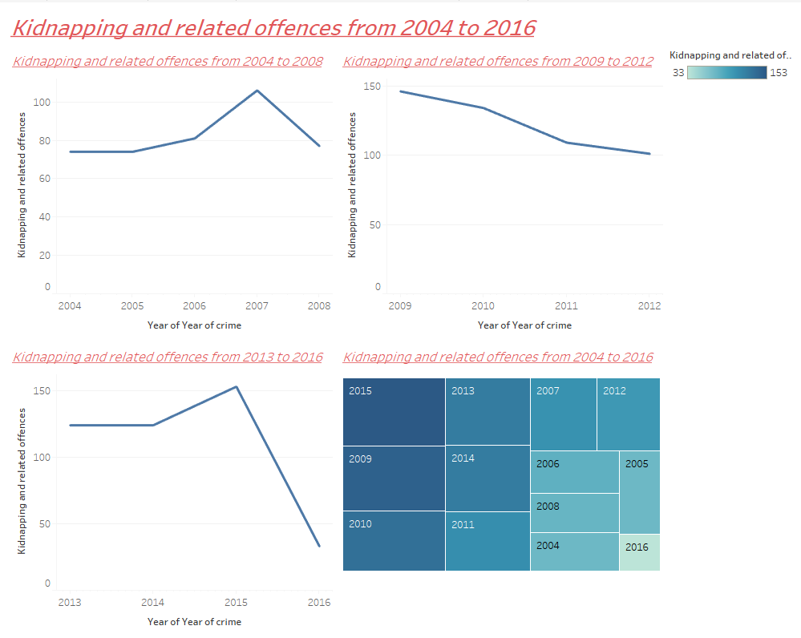

Kidnapping and related offences from 2004 to 2016: Dashboard 14
In dashboard 14 I took the Kidnapping and related offences from 2004 to 2016 and analysed the activity of this offence in three chunks e.g.2004 to 2008, 2009 to 2012, and 2013 to 2016. The line graph is getting high at 2015, 2009, 2010, 2013, 2014 and 2011 but it is getting low and down at 2016; that means that the Kidnapping and related offences are going low in 2016. In the fourth sheet I took analysis of 2004 to 2016 years of kidnapping and related offences. 2015 is the year of most Kidnapping and related offences.

Dashboard 15:
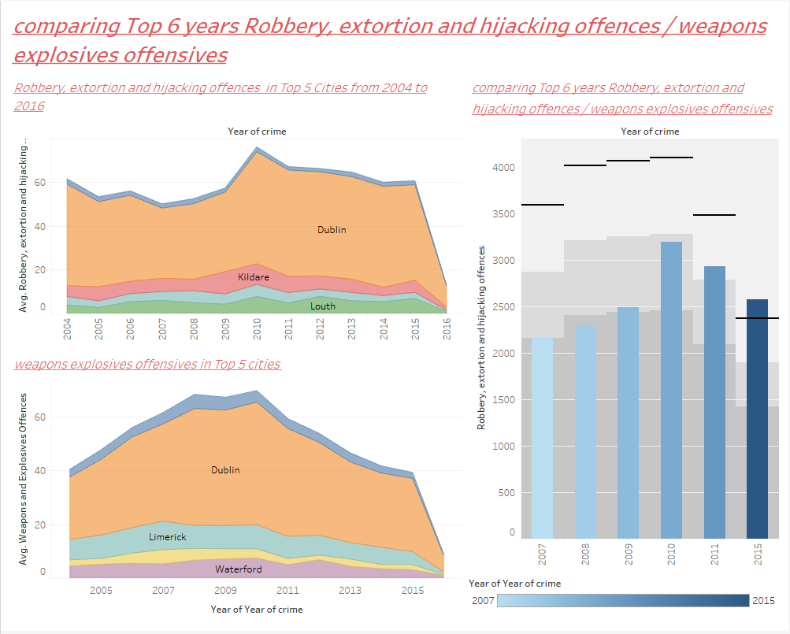

Comparing Robbery, Extortion and hijacking offences / weapons explosives offences from 2004 to 2016 in top 3 cities and top 6 years: Dashboard 15
In dashboard 15 I took Robbery, Extortion and hijacking offences / weapons explosives offences from 2004 to 2016 and analysed the activity of these offences in top 5 cities. Dublin, Kildare and Louth in relation to the Robbery, Extortion and hijacking offences were in top 3 cities respectively; These offences were high in 2010 and 2011. Weapons explosives offences from 2004 to 2016 in top 3 cities were Dublin, Limerick and Waterford respectively. These offences were high in 2007, 2009 and 2011.

Dashboard 16: Summary of Findings
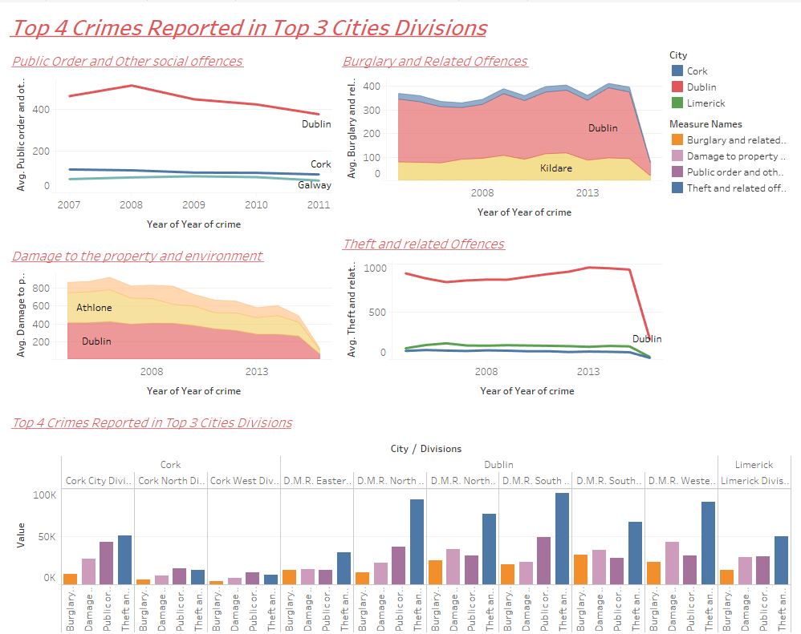

Top 4 crimes reported in top 3 cities: Dashboard 16
Summary of all dashboards/ important findings
In dashboard 16; I took the top 4 offences that are theft and related offences/ Public order and other social code offences / Damage to property and related offences / Burglary and related offences from 2004 to 2016 respectively. I analysed the activity of these offences in three-line graphs from 2004 to 2016. In 2013 most of the theft and related offences occurred. 2008 is the year of most Public order and other social code offences happened. The years when most of Damage to property and related offences / Burglary and related offences happened in 2006 and 2015 respectively. The offences are getting low towards 2016. All of these crimes were positioned mostly in Dublin, Cork and Limerick. The maximum reports are recorded in D.M.R South division of Dublin, Cork city division of Cork and Limerick Division of Limerick.

Statistical modelling using Weka

Using garda_stations.csv on Weka:
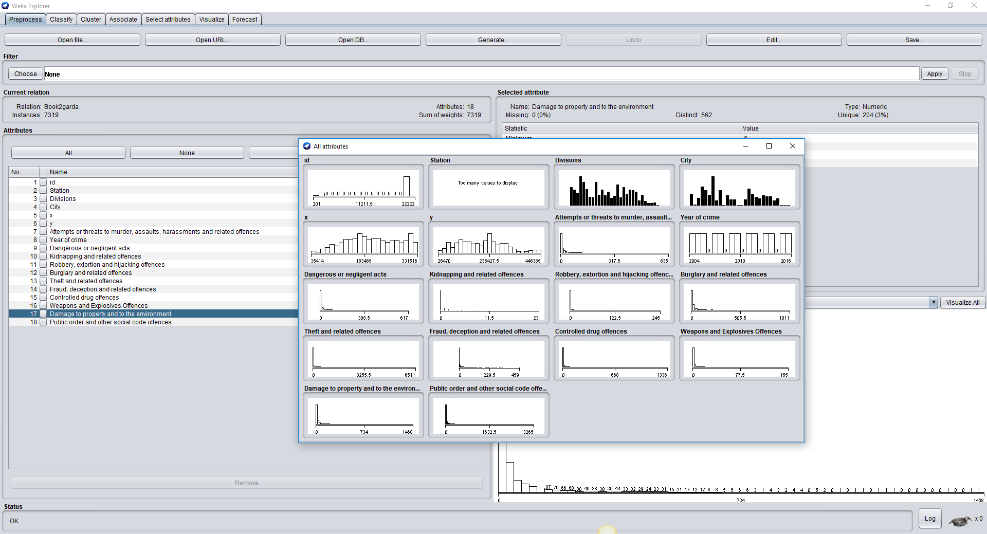

Why used K-means for analysis?
I used implementations of K-means as it allows numerical values for attributes. I used the normalize values of attributes that are measured on substantially different scales as WEKA provides filters to accomplish all of these preprocessing tasks, they are not necessary for clustering in WEKA. This is because WEKA Simple K-Means algorithm automatically handles a mixture of categorical and numerical attributes. Furthermore, the algorithm automatically normalizes numerical attributes when doing distance computations. The WEKA Simple K-Means algorithm uses Euclidean distance measure to compute distances between instances and clusters.
The purpose of clustering is to group crime incidents into hot spots. To generate the clusters using a nearest-neighbour technique, incidents are first compared to one another and the distance between each pair of incidents is calculated

K-Means Clustering technique on garda_stations.csv
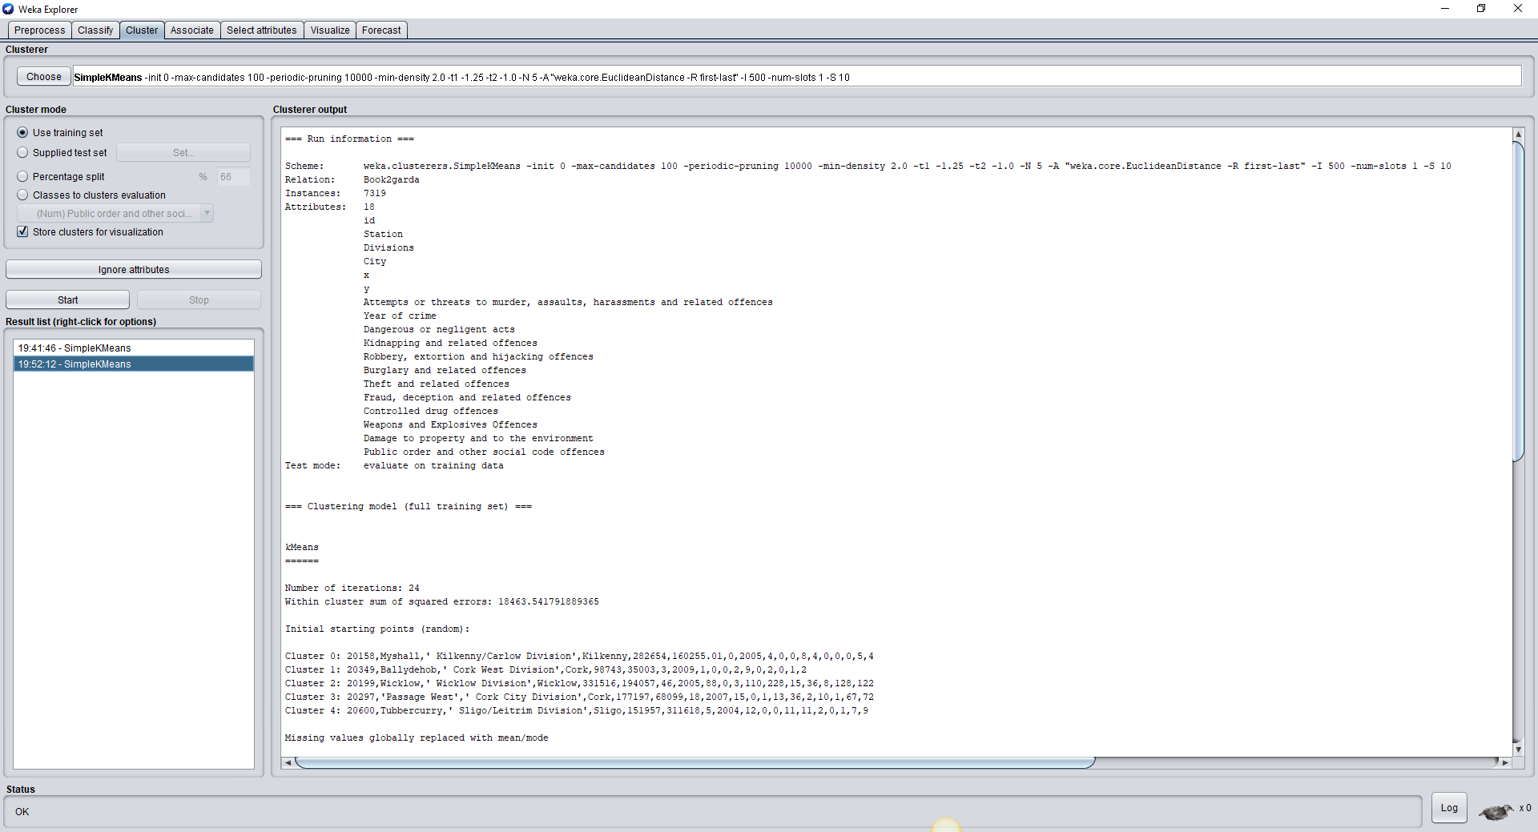

Findings of the k-means clustering on garda_stations.csv
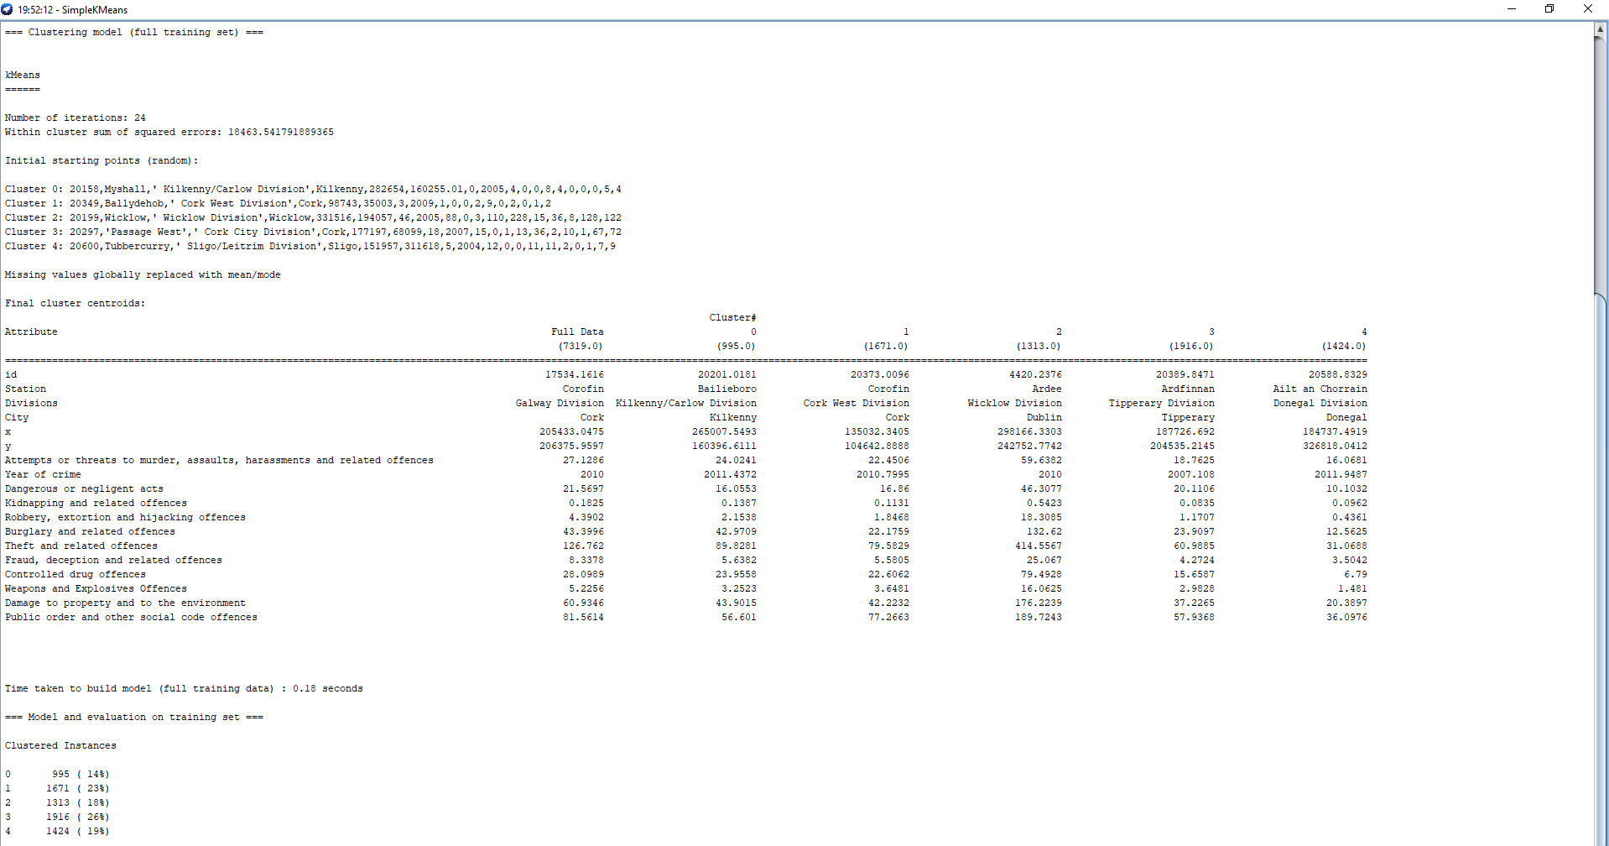
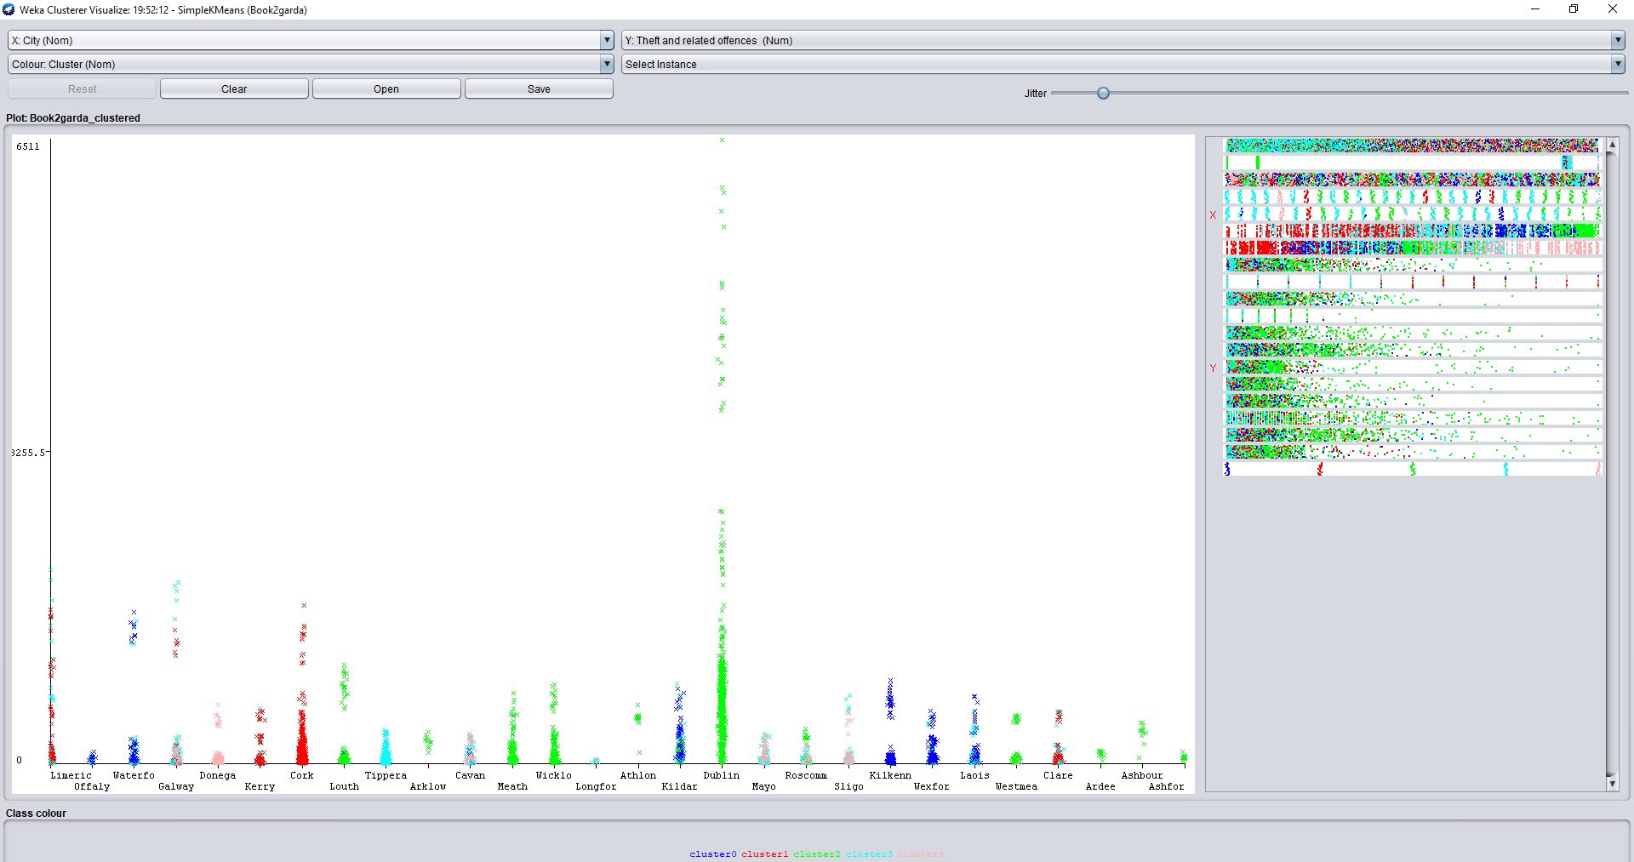
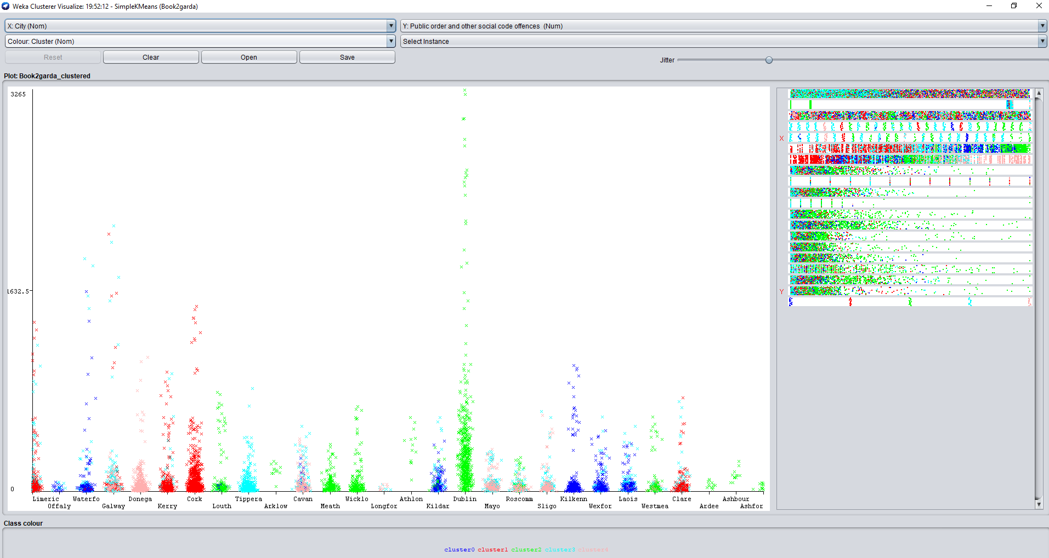
Findings of the analysis
There are five cluster formed in it cluster 0 have 995(14%) of data, cluster 1 have 1671 (23%), cluster 2 have 1313 (18%) of instances, cluster 3 have 1916 (26%) of instances and cluster 4 have 1424 (19%) of instances in it. It is also showing clearly on the visualization window. Same results as training data. Cluster 3 have the most instances in its cluster but the cluster this is more important to us is the cluster no. 2 which shows that Wicklow division of Dublin has the more reports recorded in Ardee station around 2010. There are 414 reports recorded of theft related offences, 189 recorded reports of public and other social code offences, 176 cases of Damage to property and to environment and 132 cases of Burglary and related offences recorded in Dublin, which are more than any cluster. You can analyze it on the visualization window that Dublin has the High amount of these offences and it is showing with green clusters.

Forecasting:

Using the linear Regression Model

For this purpose, I chose to apply forecasting technique using linear regression model on the most happening offence Theft and related offences. I used the original csv file for this purpose and took two values Theft and related offences in 2015 and Theft and related offences in 2016 to analyse and forecast based on these values. The linear regression model is going to forecast the next ten years of happening of the theft and related offences. I want to predict 10 years of Theft and related offences in future so I took value 10 to predict that.

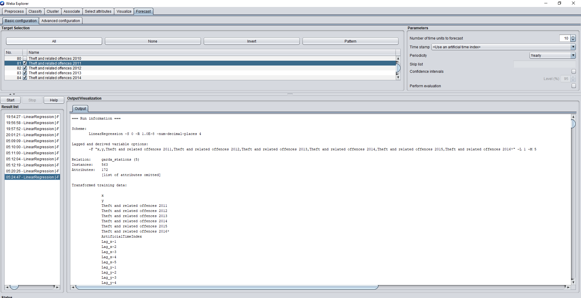
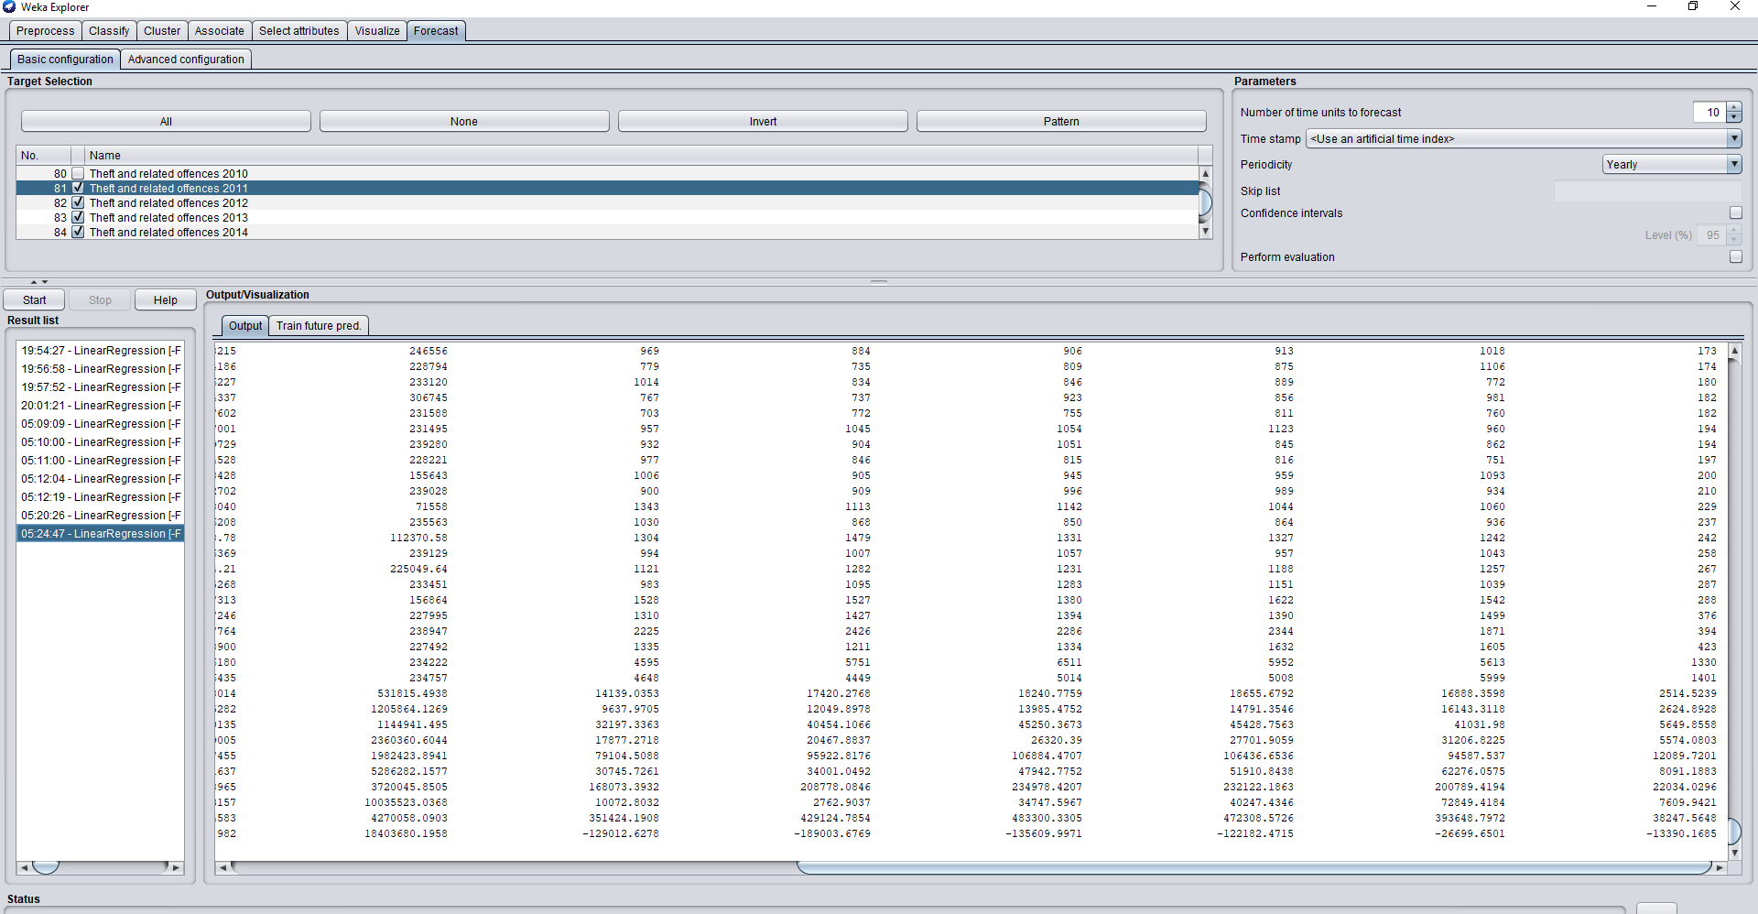
Results of forecasting / actionable analytics
According to the results of Theft and related offences in 2011, 2012, 2013, 2014, 2015 and 2016 there will be 2514 offences in 2017, 2624 in 2018, 5649 in 2019, 5574 in 2020, 12089 in 2021, 8091 in 2022, 22043 in 2023, 7609 in 2024 and 38247 in 2025. these results could be used for the future analytics.

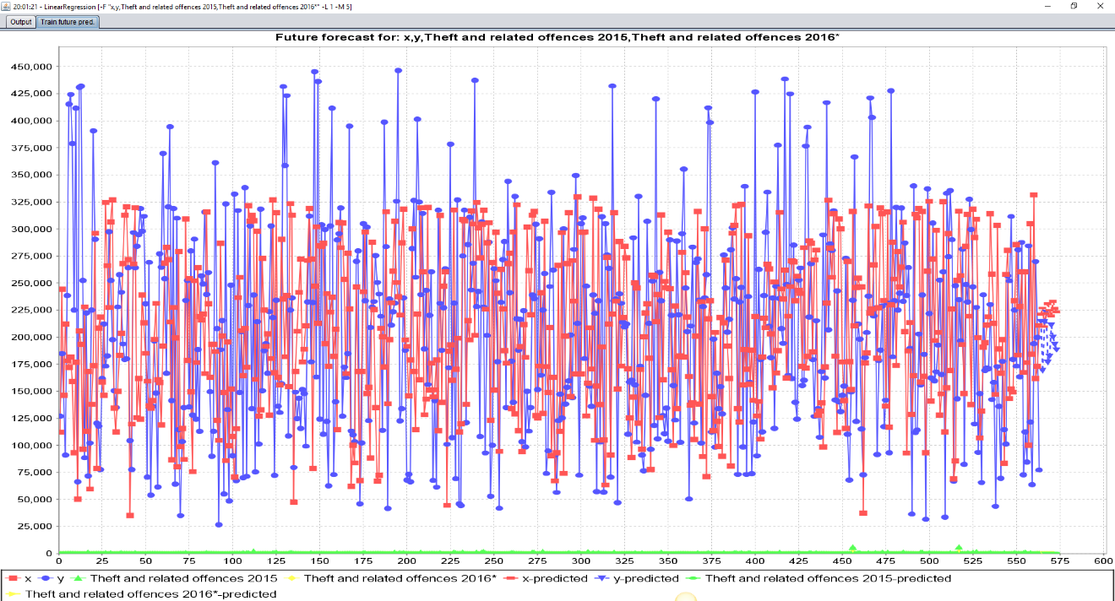
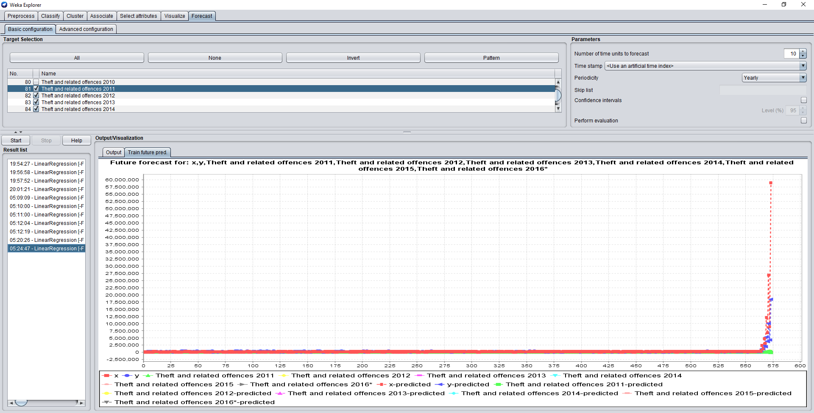

Conclusion
After applying Tableau and Weka analysis on garda stations dataset for Ireland crime statistics the results show that are theft and related offences from 2004 to 2016 are very high than other offences. I analysed the activity of these offences in tableau visualisation and statistical tool, Weka k means and timeseries from 2004 to 2016. There are the same results showing on both visualisation tools. The results show that 2013 most of the theft and related offences occurred. The offences are getting low towards 2016. All of these crimes were positioned mostly in Dublin, Cork and Limerick. The maximum reports are recorded in D.M.R South division of Dublin, Cork city division of Cork and Limerick Division of Limerick.
Actionable insights
These analytics has given us insights that can help to reduce crimes and reshape criminal investigations. It could help to predict the smarter way to forecast where the garda officers should patrol. It could help and serve the citizens of Ireland in New Hampshire. These analytics could help to reduce the robberies, burglaries and theft.

Poster 1:
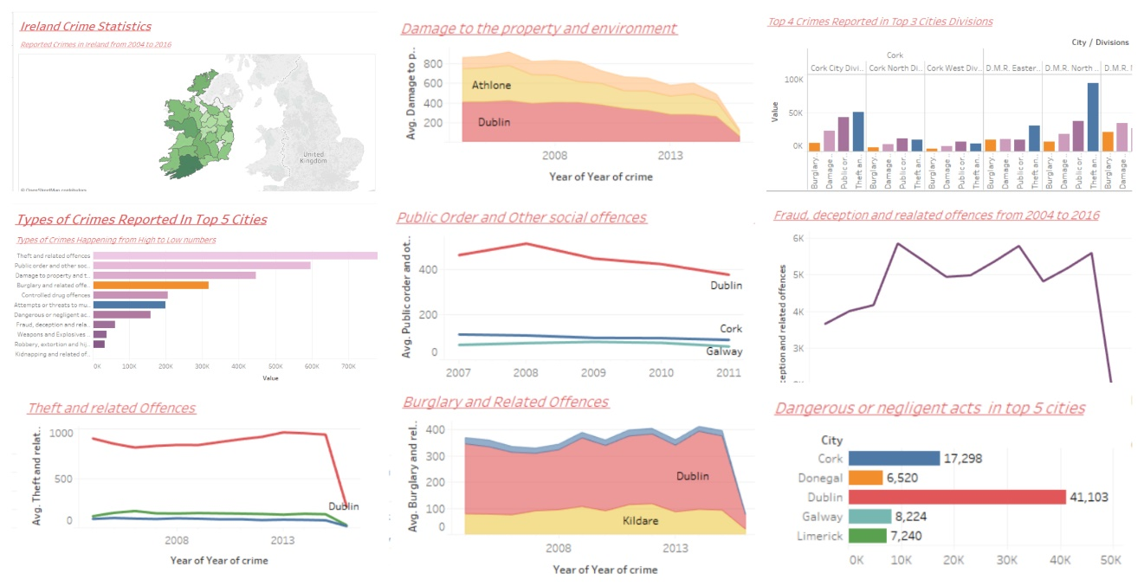

Poster 2:
